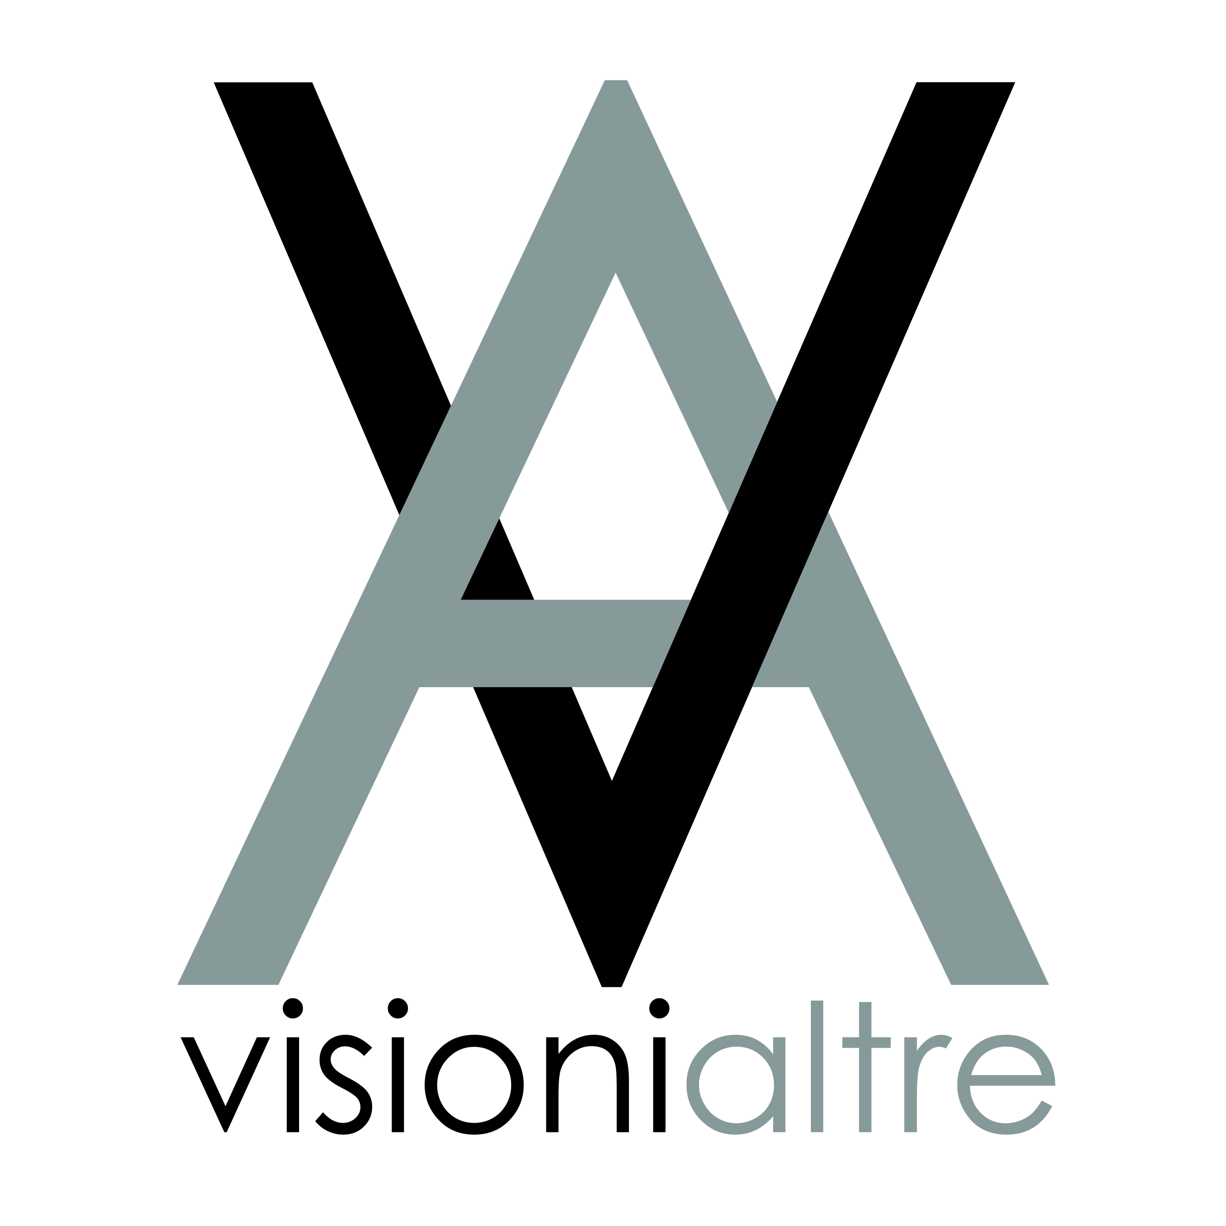

www.visionialtre.com
Campo del Ghetto Novo 2918
30121 VENEZIA
c.f. 91025540286

VISIONI ALTRE AWARD 2022 - 1st edition

VISIONI ALTRE
Association based in VENEZIA, campo del Ghetto Novo n. 2918
in collaboration with G'art [galleria delle arti]
Association based in VENEZIA, Sestiere Cannaregio 4958

promotes:

International Prize for Contemporary Art

Art direction: Adolfina de Stefani
Project assistant: Paola Caramel

With the International Prize for Contemporary Art - First edition -
Visione Altre, a non-profit association, aims at researching and promoting innovative positions in visual art. The aim is to encourage artistic research, support creative activity, encourage the development of ideas and works that are not bound by market constraints, and to present them to the public through exhibitions and events and present them to the public through exhibitions and publications.
The competition envisages collaborations with art galleries, companies, authors of critical texts as well as inclusion of the first three winning artists in the ART ON Gallery online sales portal;
the participation in the collective exhibition, divided into three periods, in VENICE at the gallery VISIONI ALTRE of the selected artists.

WHO IS INVITED
All artists of all expressions concerning visual art are invited to apply without limits of age, gender, nationality or other qualification. For underage artists, the consent of the parental authority is mandatory.

CANDIDACY
In order to participate in the selection, each artist may submit a photographic portfolio of one or more of the most representative works, for a maximum of 10 works no later than 30 June 2022 to one of the following addresses:
infovisionialtre@gmail.com - gartvenice@gmail.com

The theme is free.
Participation in the pre-selections is free of charge.
Below are the accepted techniques.
If pairs or groups of artists apply, they will be considered as a single entity for the purposes of winning the Prize.

PRIZE STRUCTURE
Once the portfolios have been received, the jury* in charge, made up of experts in the field, will examine the works in order to make a preliminary selection and announce the participants in the competition by 31 August 2022.

From the 1st to the 30th of September 2022 the selected artists will send to the following email addresses:
infovisionialtre@gmail.com - gartvenice@gmail.com the confirmation of adhesion and the receipt of the payment of €70,00 as a contribution for the registration to the Associations Visioni Altre and G'art [galleria delle arti] and to receive the respective membership cards for the year 2023.

From 1st to 31st October 2022 the artists will have to send the work selected by the jury to the VISIONI ALTRE Gallery in Venice, which will organise three exhibitions divided as follows:

1st period 26 November - 11 December 2022 | Exhibition of 33 works
2nd period 17 December 2022 - 8 January 2023 | Exhibition of 33 works
3rd period 14 - 31 January 2022 | Exhibition of 33 works

All the works of the selected artists will be exhibited and distributed, by the organisers, over the three exhibition periods. The artists will be informed about their exhibition period and relevant opening and closing dates on 1 November 2022.

The announcement of the winners and subsequent award ceremony will take place during the finissage of the third exhibition: 31 January 2023.
In addition to the winners chosen by the jury, a special mention will be given by visitors to the three exhibitions, during which they will be invited to vote for their favourite work, giving reasons for their choice.

The organisation undertakes to send personal invitations to the prize-giving ceremony - and the conclusion of the exhibition - by email to all the selected artists.
Before and during the exhibition periods, articles about the Award and the Exhibition will be published on various cultural and artistic websites.

*JURY
The candidate works will be assessed by 5 national and international jurors who will be announced from 1 October 2022 and who will select the finalist artists. The selection criteria are geared towards evaluating the proposed work in terms of originality, innovation, creative intelligence, conceptual and design faculty, aesthetic persuasion, relevance of content and capacity for further evolution. The final choice will focus on a particularly valid and significant work, which stands out in the artistic field - both Italian and international - and which makes a contribution to the current artistic debate.

PRIZES AND AWARDS

1st PRIZE Award of 1000 euros + Free entry in www.art-ongallery.com*
In recognition of the originality/exclusivity of the work and its conception.

2nd PRIZE 500 euros + free entry to www.art-ongallery.com* In recognition of outstanding artistic achievement.

3rd PRIZE 300 euros + free entry to www.art-ongallery.com* in recognition of outstanding talent as an artist.

4th PRIZE Special mention + Promise of exhibition for the year 2023** To the artist who has distinguished himself or herself by special features.

5th PRIZE Special Mention + dedicated article in the www.art-ongallery.com magazine* To the work most appreciated by the public.

6° PRIZE 10 personalised selection certificates signed by the members of the Committee

*Art On Gallery is a marketing platform for artists, designers and craftsmen who want to successfully promote and market their work online. The artistic direction is by G'art [galleria delle arti].
**At the Visioni Altre gallery in ways and times to be agreed upon

CHARACTERISTICS OF WORKS AND TECHNIQUES ALLOWED
Dimensions of the work:
painting/photography/digital art/street art projects must not exceed the size 100x100cm
Sculpture must not exceed the dimension 50x50x50cm
Installation may not exceed dimensions 100x100x100cm

Works may be produced in complete stylistic and technical freedom (oil, tempera, acrylic, ink, vinyl, watercolour, graphite, pencil, collage, etchings, engravings, various types of print, etc.) and on any medium (canvas, paper, wood, plastic, iron, etc.).

Sculpture and Installation
Works created in any organic or inorganic material are permitted. They may make use of sound, light, video and mechanical or electrical movements.
Maximum weight allowed: 10 kg.

Photographic art
Photographs or series of photographs on analogue or digital media, in colour or black and white, are permitted.

Video Art
Videos, slow motion, time-lapse and works made using all animation techniques on any digital or analogue medium are permitted. Maximum duration 10 minutes. To apply, the video file must be uploaded online and must not exceed 500 mb.

Digital Art
Works made with computers or using digital applications and devices are eligible: installations in which the use of digital media plays a significant role in terms of creative process and content; net art, software, interactive devices, augmented reality and virtual art projects, rapid prototyping etc. Works involving an installation should be adaptable to the available exhibition space.

Urban and Street Art Project
Urban art, redevelopment, street art, graffiti and stencil art projects are allowed, where the artistic intervention is in relation to the urban fabric and the public space for which it is conceived and can involve the use of any technique (spray cans, artistic stickers, normographic art, video projections, installations, etc.). There are no limitations in the choice of the place of the planned intervention. The finalist projects will be displayed on explanatory panels.

IMPORTANT | READ CAREFULLY
1_ NO LATER THAN 30 September 2022 confirmation of participation in the project by emailing SCHEDULE no.1 completed in its entirety + receipt of payment of the contribution.

2_ NO LATER THAN 31st October 2022 the work must be sent to the address indicated below. Each work must not exceed the maximum dimensions allowed (with a deviation of 2/3 cm). Works that do not meet the above criteria will not be accepted.
The work must contain: title and signature of the artist.
The artwork must be accompanied by the completed entry form no. 2.

Address for sending works : VISIONI ALTRE / Adolfina de Stefani Cannaregio 2918
30121 VENICE - ITALY

IT IS ADVISABLE
Make sure the shipment is traceable.
Please write on the package the recipient's mobile phone number: +39 3498682155. Do not send perishable items or items made of dangerous materials/substances, glass or other excessively fragile material.

IMPORTANT
At the end of the exhibition, the organisation undertakes to return the work to the artist by hand; if the artist or a person delegated by him fails to collect the work, it shall be considered donated to the Archive.

If the return of the work is desired, please write in your own hand the indicated wording and attach it to the work; in case of omission, the work is to be considered as donated to the Archive.

For the return of the work with shipment in Italy, attach the receipt of the bank transfer of € 15,00 made on the bank account entitled to: VISIONI ALTRE/Adolfina De Stefani

IBAN code IT10 Z030 6909 6061 0000 0150759
BIC-SWIFT - BCITITMM
Bank Intesa Sanpaolo Spa

For return shipments from Italy to abroad, please check costs in advance with the organisation.

For organisational reasons, the return of the wrapping (box or other form of packaging) used for the shipment of the work is not guaranteed.

The organisation declines all responsibility for any theft or damage that may occur during transport and installation.

For the resolution of any possible controversy related to the VISIONI ALTRE AWARD 2022 edition, the Court of Venice shall have exclusive jurisdiction.

Adolfina de Stefani
Responsabile della galleria VISIONI ALTRE
Tel: +39 349 8682155 | adolfinadestefani@gmail.com

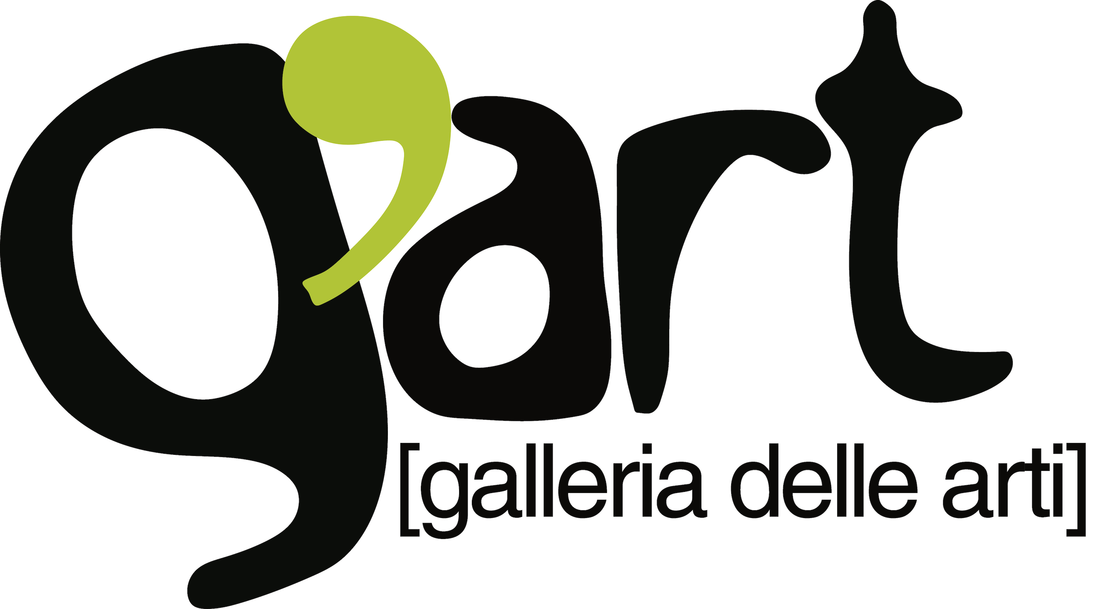

Desciption sheet n.1
To be filled and send it back e-mail | Delivery deadline: September 30 2022
The undersigned................................................................................................. born/a......................................................the ......................................................
resident to.................................................................. Province........................
Posta lcode........................Street.....................................................................
tel.fisso..............................................cell........................................................... ee-mail....................................................... sito web............................................
Declares to participate at the VISIONI ALTRE 2022 Award and to accept its organisational procedures.

He/she also encloses the receipt of the payment of € 70,00 made on the bank account of VISIONI ALTRE/Adolfina De Stefani.
Codice IBAN IT10 Z030 6909 6061 0000 0150759
BIC-SWIFT - BCITITMM
Banca Intesa Sanpaolo Spa

Date____________________________ Signature____________________________________________________
Address for sending works :
VISIONI ALTRE / Adolfina de Stefani
Cannaregio 2918 30121 VENEZIA - ITALIA

Contatti:
Galleria Visioni Altre fisso + 39 0415246039 ; cell+39 349 8682155;
mail: adolfinadestefani@gmail.com
G’art [galleria delle arti] + 39 339 664 2086 | paolacaramelmail@gmail.com

Galleria Visioni Altre | Campo del Ghetto Novo 2918 - 30121 VENEZIA ITALIA

Desciption sheet n.2
To attach to the work | deadline: October 31, 2022
The form can be created independently as long as the following guidelines are respected:
A/4 format, max one page, Arial font, font seze 12
And must necessarily contain:
Author
Title
Technical work/ interpretation

Sending works to :
VISIONI ALTRE | Adolfina de Stefani
Cannaregio 2918
30121 VENEZIA - ITALIA

Contacts:
Galleria Visioni Altre fisso + 39 0415246039 ; cell+39 349 8682155; mail: adolfinadestefani@gmail.com
G’art [galleria delle arti] + 39 339 664 2086 | paolacaramelmail@gmail.com

Galleria Visioni Altre | Campo del Ghetto Novo 2918 - 30121 VENEZIA - ITALIA

